DBA5102 Business Analytics Capstone Project
Roy Yeo Fu Qiang
Investment Context Engine (ICE): A Lightweight, Cost-Effective Graph-Based Context-Aware AI Backbone for Lean Investment Funds

1. Executive Summary
Problem: Lean hedge funds drown in fragmented, unstructured data (filings, transcripts, notes, news), but lack the infrastructure and manpower of large investment funds. This causes missed early signals, low insight reuse, inconsistent context, and manual triage bottlenecks, leaving small funds at structural disadvantage versus larger peers.
Opportunity: Frontier AI (LLMs, RAG) is commoditised; the true edge is context engineering—encoding the fund’s proprietary knowledge, drivers, and mental models into a reusable, explainable, and compounding system that can ground the LLMs or AI tools into giving more meaningful outputs.
Solution: ICE — a graph-native, MCP-ready context engine integrating external + internal data into a domain-specific knowledge graph queried via Lazy Graph-RAG + Hybrid Retrieval.
- Grounds LLM reasoning in fund-specific context.
- Delivers traceable, causal, decision-ready insights for research, portfolio monitoring, and risk.

2. Key Differentiators
Spine, not muscle: Build proprietary cognitive core, turning fragmented noise into a compounding, explainable knowledge assets that powers sharper and more confident investment decisions; buy external tools (plug in via MCP).
Lazy Graph-RAG: On-demand, sparse, high-signal subgraph retrieval; minimal upfront KG build.
Hybrid Retrieval: Vector + keyword + HyDE + graph traversal
Full Traceability: Every claim has timestamp, source, evidence snippet; unsupported facts dropped.
Single deterministic agent: Consistent extract → reason → synthesize pipeline.

3. MVP Scope (~4 to 6 months)
Coverage: S&P 500 equities; focus on portfolio monitoring + fundamental research.
Edge Types (MVP)
  - Ownership Context Edge: Portfolio → holds → Company
  - Thematic Edge: Company → exposed_to → Theme
  - Anchor KPI Edge: Company → key_driver → KPI
Hop Depth: Incremental 1-hop → 2-hop → 3-hop retrieval with forward/reverse traversal, temporal/confidence scoring.
UI Modules:
- Ask ICE (QA w/ causal paths + citations)
- Per-Ticker Intelligence Panel (“What Changed”, drivers, exposures)
- Mini Subgraph Viewer (1-3 hops)
- Daily Brief Table (portfolio/watchlist)

4. Business Value
Time savings: ≥30 min/day per analyst → faster triage and more focus on alpha generation.
Alpha: Minutes-earlier signal capture can drive 1% profit difference, amounting to ~$1M for $200M book; studies show +3–5% annualized abnormal returns from GenAI adoption.
Risk Control: Human-in-the-loop, evidence-backed insights → reduces costly hallucinations.
Institutional Memory: Knowledge compounds with every query, note, and data ingestion.

5. Build Plan & Feasibility
Phased Roadmap:
  - Basic RAG MVP
  - Hybrid Retrieval + Lazy Graph Links
  - Context Processing + Synthesis Refinement
  - Deployment (batch briefs + UI)
  - Batch KG Enrichment
Tech Stack: Python + FAISS + NetworkX + local embeddings + GPT (selective) + Streamlit UI.
Zero-ops: Laptop-scale, open-source, no backend infra needed for MVP.

6. Risks & Mitigation
Risk | Mitigation
Lack of Data | Start with public, free corpora. Ingest portfolio CSVs, utilize synthethic data for development and to showcase business value.
Sparse / Stale KG *** | Seed a minimal high-signal schema (e.g. portfolio or sector information); combine with web search tools
Lack of Budget | Lazy Graph expansion over full KG build, consider NetworkX over Neo4J for graphs storage; reduce scope; prioritise local LLMs
Hallucination Risk | Main objective of adopting a Graph-RAG with traceability and human-verification in workflow
Token bloat / Over-reliance on external LLMs | Retrieval plan with budgets: per-hop top_k caps, MMR de-dup, recency & confidence filters; hierarchical extractive summaries.
Conflicting views | Don’t auto-resolve; show both - side-by-side narratives
Regime drift | Temporal metadata, rolling windows in retrieval

7. Possible / Future Extensions
- Using hallucinated graph structure to assist in building up the graphs (HyDE inspired)
- Full Graph-RAG
- Chat with conversational memory (context retention)
- Expanded data coverage (structured fundamentals, alt-data, internal trade logs)
- Multi-agent framework

Appendix – ICE User Interface Mockup
The MVP dashboard targets portfolio management, investment research, risk management, and trading workflows for lean equity hedge fund teams. It highlights only the most material drivers of change, explains them in human-readable terms, and grounds every insight in traceable, timestamped evidence.
Below is the phased feature breakdown of the end-user delivery, with the full mockup UI provided in Appendix J (ICE MVP User Interface Mockup):
Module 1: Ask ICE a Question (LLM Query Interface)
- Purpose: A QA query that accepts natural language queries (e.g., “Why is NVDA at risk from China trade?”) and returns structured, explainable answers.
- Output: Key drivers (e.g., supply chain disruptions, demand shifts), a causal reasoning chain, and linked source citations.
- Impact: Converts fragmented data into decision-grade insight in seconds.
- Future: Evolves into a conversational, multi-turn analysis tool.
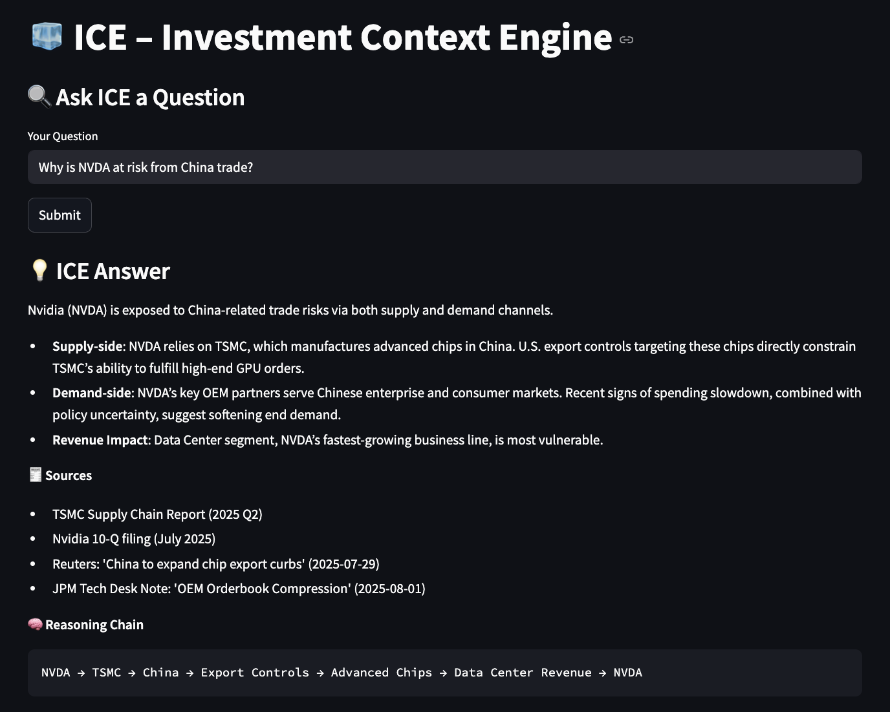
Module 2: Per-Ticker View – Intelligence Panel
- Purpose: In-depth drill-down for any company in the portfolio/watchlist or from a query.
- Features: TL;DR summary, alert priority, confidence score, recency, KPI drivers, thematic exposures, soft signals, and causal paths.
- Integration: Opens subgraph view for visual exploration; “What Changed” tracker highlights shifts in evidence, edges, or confidence.
- Impact: Balances compactness and depth—insights at a glance with the option for deeper causal analysis.
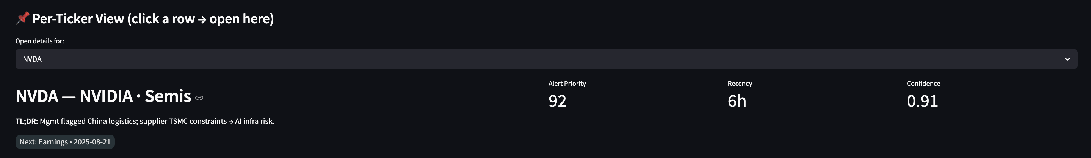
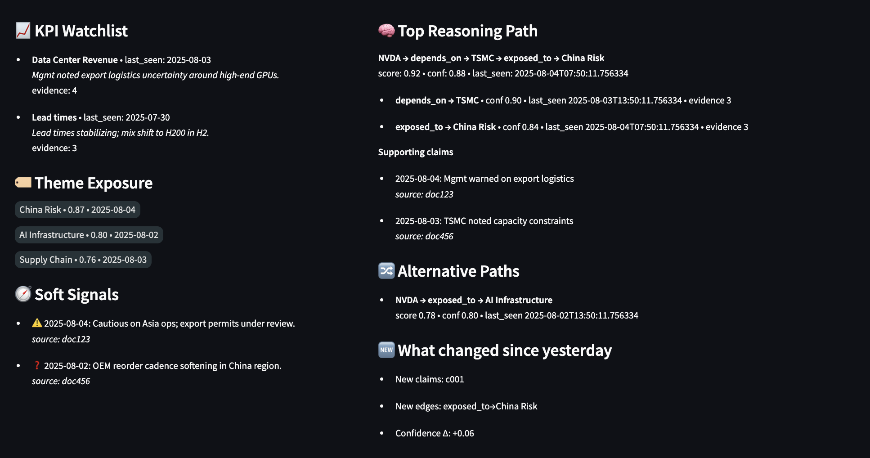
Module 3: Mini Subgraph Viewer (Linked to Per-Ticker View)
- Purpose: Interactive visualization of 1–3 hop relationships around a focal ticker, surfacing links with other entities (e.g. suppliers, KPI drivers, themes, news)
- Filters for graph: Hop depth, recency, edge type, confidence, contrarian signals.
- Impact: Makes complex interdependencies intuitive—“what’s going on and why” in a single, navigable map.
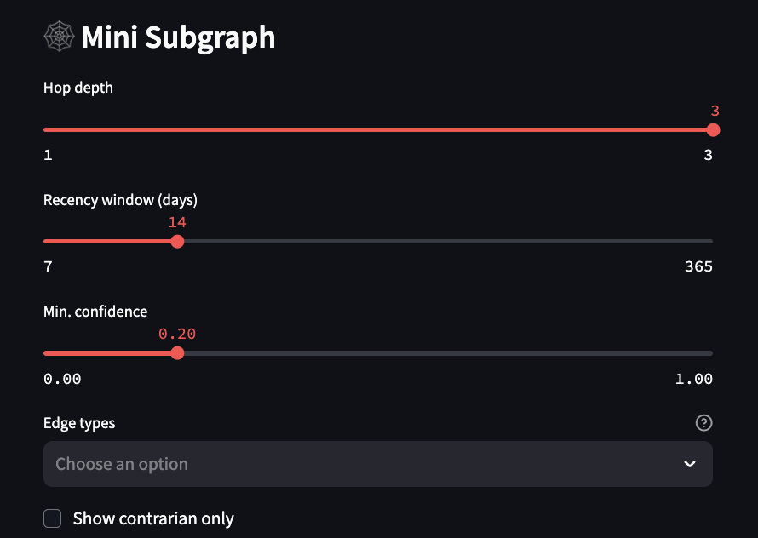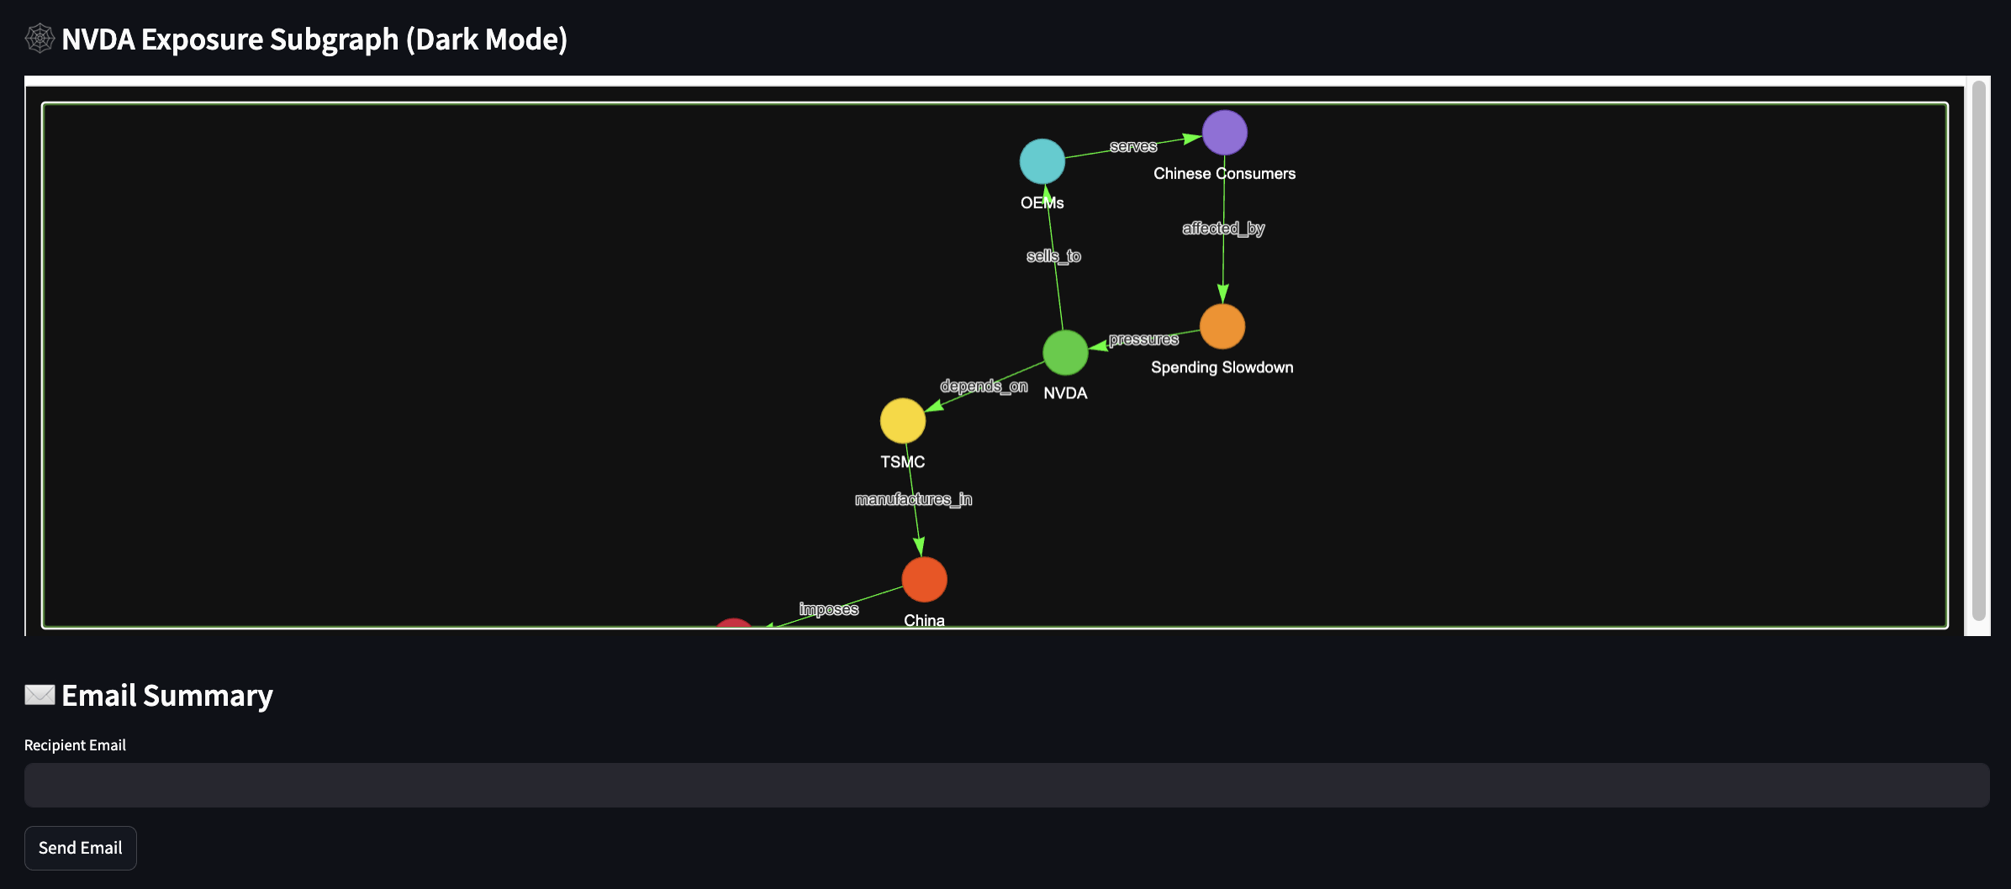

Module 4: Daily Portfolio / Watchlist Brief Tables
- Purpose: High-signal, daily-updating table of emerging risks and opportunities across names in portfolio or watchlist.
- Columns: Ticker, “What Changed”, top driver, relevant themes/KPIs, soft signals, evidence recency, confidence score.
- Workflow: Rapid triage—click on specific ticker to open detailed Per-Ticker View and interactive subgraph.
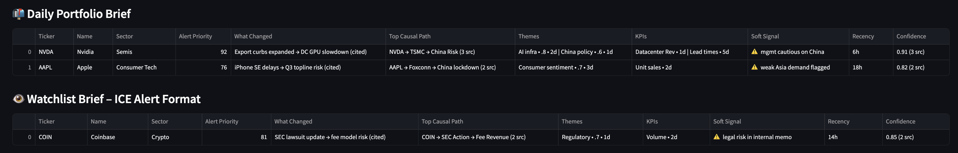
Optional Visuals
- Portfolio Sector Exposure (Pie Chart) – Sectors/Industries breakdown of portfolio holdings.
- Portfolio Theme Exposure (Bubble Chart) – Frequency & market value of holdings linked to each theme.
Module 5: Email Module
- Purpose: Lightweight delivery of ICE outputs via email—summaries, alerts, or PM digests.
- Future Extensions: Auto-push alerts, customizable templates, and periodic strategy reports.

